Science Lesson Plan (Power Generation) January 1st 2019

Greetings (2 mins)

Introduction (5 mins): Ask students if they know the meaning of “Power Generation”. Give clues, then give the answer (hatsuden in Japanese). Ask them to make partners, and make a list of types of power generation they know of. After 3 minutes, ask for volunteers to get some examples.

Hand out the worksheet and ask students to make groups of 4.

(Part I ) Matching (5 mins): Students will need some new vocabulary, so ask them to try the part 1 matching with their group. They can use dictionaries. After 3 minutes, check and give the answers.

Hand out the “Power Generation Types” worksheet.

(Part II) Names and Definitions (7-10 mins): In part II, ask students to match the names from the name list and the definitions from the definition list, to the pictures on the “Power Generation Types” worksheet. If they finish, ask them to use a dictionary, and think about the meaning of the labeled parts of the picture. After everyone seems to have finished the matching, check and give the answers.

(Part III) Advantages and Disadvantages (15 mins): Ask students to turn their original worksheet to the backside for part III. Ask each group to choose their favorite power generation type and think about the good points and bad points, and write them in English. If they have extra time, they can draw their own picture of the power generation, and label it in their own words.

Sharing (10-12 mins): Ask students to stand up, take their papers, and sit in a new group (randomly, or an organized shuffle is fine). It is ok if some members chose the same power generation, as they may have different advantages and disadvantages. Each member of the new groups will then introduce their chosen power generation. They should introduce it, talk about the good points and bad points, and talk about the picture.

Closing Greetings: Ask students to go back to their original formation, and ask questions about some power generation types. (1-2 mins)

(*Future lessons will ensure that all students are exposed to the advantages and disadvantages of all power generation types)

Name:
Power Generation Types
Definition: .
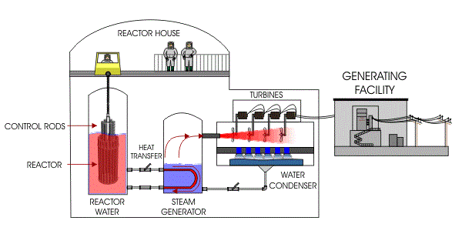
Name:
Definition: .
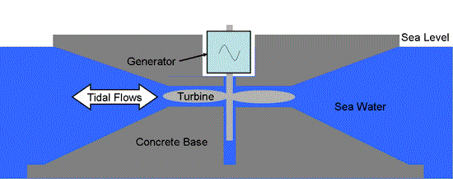
Name:
Definition: .
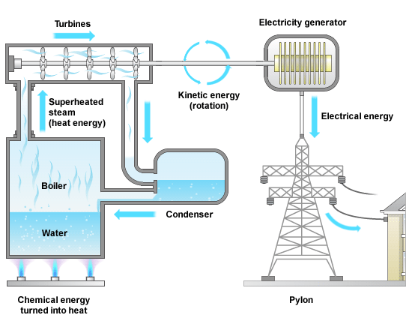

Name:
Definition: .
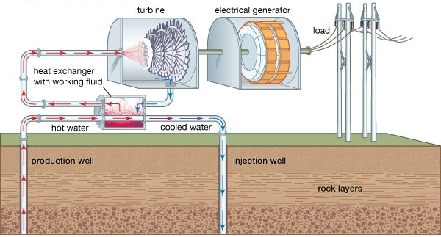

Name:
Definition: .
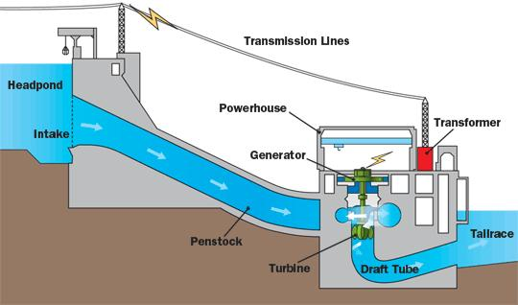

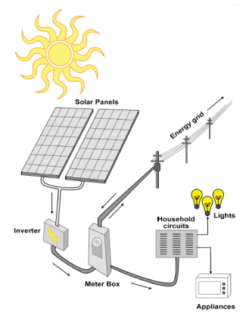

Name:
Definition:

.

Power Generation

Part I:
Chemical reaction 放射性物質

Power generation 化学反応

Radioactive substance 潮、潮汐

Potential energy 位置エネルギー

Tides 発電

Name List | Meaning List
- Tidal Power  - Nuclear Power  - Solar Power  - Thermal Power  - Geothermal Power  - Hydro Power | - Power generation from radioactive substances.  - Power generation from heat from inside planet Earth.  - Power generation from sunlight.  - Power generation from the movement of tides.  - Power generation from the potential energy of water.  - Power generation from chemical reactions.
Part II:
Match the names and meaning to the pictures on the “Power Generation Types” worksheet.

Power Generation
Part III:
Picture:

Good Points | Bad Points
-  -  -  -  - | -  -  -  -  -

